**JUnit_Basic Testing Exercises**

**Exercise 1: Setting Up Junit**

**Step1** : Create a new Java project in your IDE(Eclipse)

**Step2** : Add JUnit dependency to your project.

<project xmlns="http://maven.apache.org/POM/4.0.0" xmlns:xsi="http://www.w3.org/2001/XMLSchema-instance" xsi:schemaLocation="http://maven.apache.org/POM/4.0.0 https://maven.apache.org/xsd/maven-4.0.0.xsd">

<modelVersion>4.0.0</modelVersion>

<groupId>com.junitsetup</groupId>

<artifactId>practice</artifactId>

<version>0.0.1-SNAPSHOT</version>

<dependencies>

<dependency>

<groupId>junit</groupId>

<artifactId>junit</artifactId>

<version>4.13.2</version>

<scope>test</scope>

</dependency>

</dependencies>

</project>

**Step 3:**

**GreetingService.java**

package practice;

public class GreetingService {

public String greet(String name) {

if (name == null || name.isEmpty()) {

return "Hello, Guest!";

}

return "Hello, " + name + "!";

}

}

**GreetingServiceTest.java**

package practice;

import static org.junit.Assert.*assertEquals*;

import org.junit.Test;

public class GreetingServiceTest {

@Test

public void testGreetWithName() {

GreetingService service = new GreetingService();

String result = service.greet("Madhumala");

*assertEquals*("Hello, Madhumala!", result);

}

@Test

public void testGreetWithEmptyString() {

GreetingService service = new GreetingService();

String result = service.greet("");

*assertEquals*("Hello, Guest!", result);

}

@Test

public void testGreetWithNull() {

GreetingService service = new GreetingService();

String result = service.greet(null);

*assertEquals*("Hello, Guest!", result);

}

}

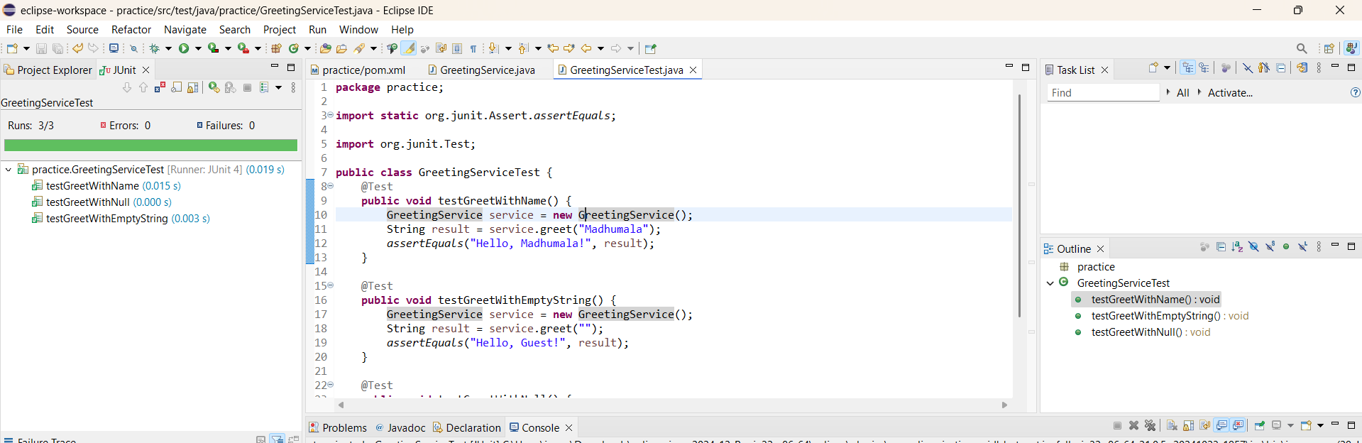

**Exercise 3: Assertions in JUnit**

**AssertionsTest.Java**

**package** practice;

**import** org.junit.Test;

**import** **static** org.junit.Assert.*;

**public** **class** AssertionsTest {

@Test

**public** **void** testVariousAssertions() {

// Assert equals

*assertEquals*("Sum should be 10", 10, 7 + 3);

// Assert true

*assertTrue*("This should be true", "OpenAI".startsWith("O"));

// Assert false

*assertFalse*("Should be false", 100 < 50);

// Assert null

String name = **null**;

*assertNull*("Name should be null", name);

// Assert not null

String city = "Hyderabad";

*assertNotNull*("City should not be null", city);

}

}

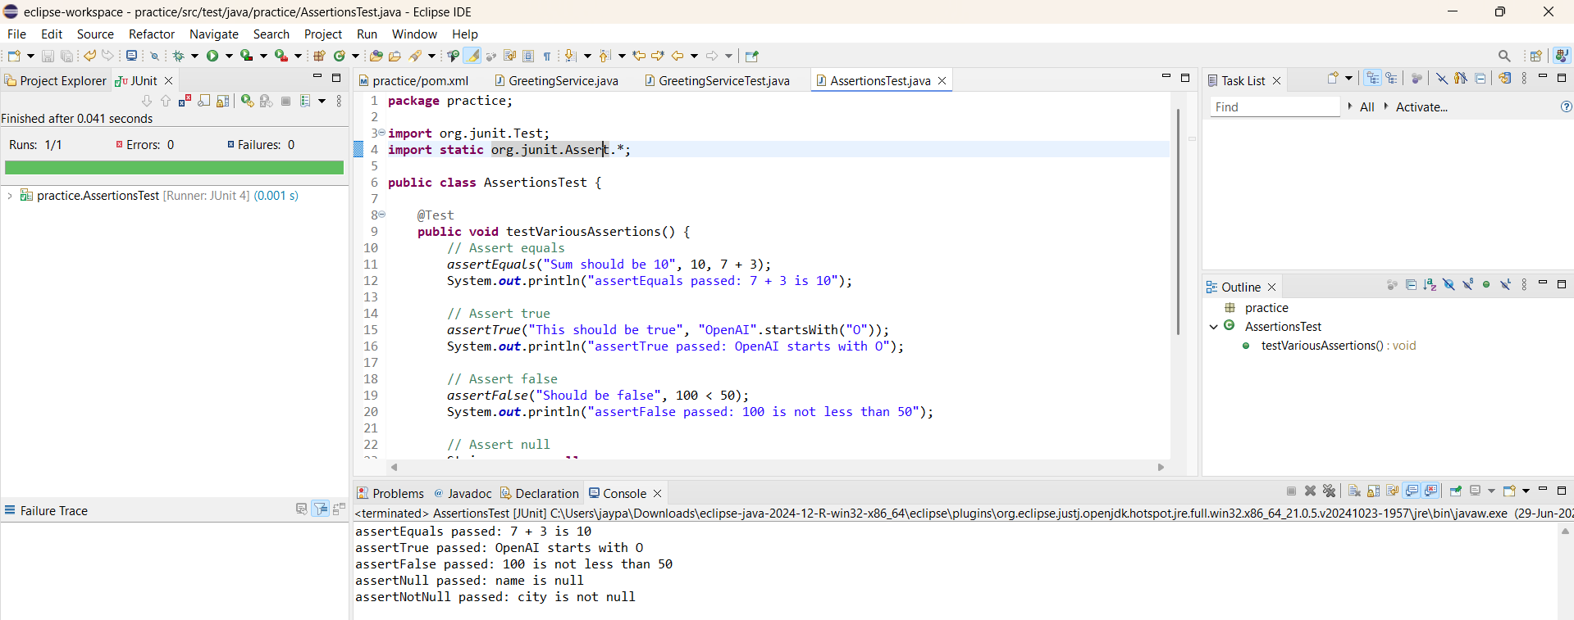

**Exercise 4: Arrange-Act-Assert (AAA) Pattern, Test Fixtures, Setup and Teardown Methods in Junit**

**ServiceTest.java**

package practice;

public class ServiceTest {

public String greet(String name) {

return (name == null || name.isEmpty()) ? "Hello, Guest" : "Hello, " + name;

}

}

**ExampleServiceTest.java**

package practice;

import org.junit.Before;

import org.junit.After;

import org.junit.Test;

import static org.junit.Assert.*;

public class ExampleServiceTest {

private ServiceTest service;

@Before

public void setUp() {

service = new ServiceTest();

}

@After

public void tearDown() {

service = null;

}

@Test

public void testGreetWithName() {

String input = "John";

String result = service.greet(input);

*assertEquals*("Hello, John", result);

System.out.println("testGreetWithEmpty passed with result: " + result);

}

@Test

public void testGreetWithEmpty() {

String input = "";

String result = service.greet(input);

*assertEquals*("Hello, Guest", result);

System.out.println("testGreetWithEmpty passed with result: " + result);

}

}

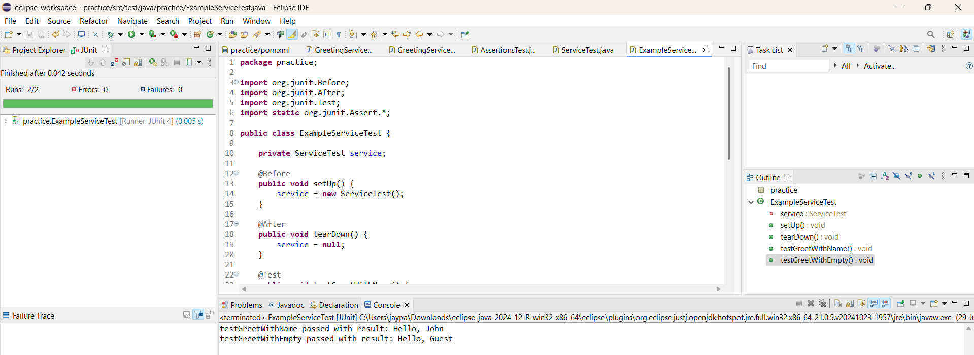

Mockito exercises

**Exercise 1: Mocking and Stubbing**

**Pom.xml:**

<dependency>

<groupId>org.junit.jupiter</groupId>

<artifactId>junit-jupiter</artifactId>

<version>5.9.1</version>

<scope>test</scope>

</dependency>

<dependency>

<groupId>org.mockito</groupId>

<artifactId>mockito-core</artifactId>

<version>4.8.1</version>

<scope>test</scope>

</dependency>

**ExternalAPI.java:**

package practice;

public interface ExternalApi {

String getData();

}

**MyService.java:**

package practice;

public class MyService {

private ExternalApi api;

public MyService(ExternalApi api) {

this.api = api;

}

public String fetchData() {

return api.getData();

}

}

**MyServiceTest.java**

package practice;

import org.junit.jupiter.api.Test;

import static org.junit.jupiter.api.Assertions.*;

import static org.mockito.Mockito.*;

public class MyServiceTest {

@Test

public void testFetchDataReturnsMockedValue() {

// Create a mock object for the external API

ExternalApi mockApi = *mock*(ExternalApi.class);

// Stub the method to return a predefined value

*when*(mockApi.getData()).thenReturn("Mocked Response");

// Inject mock into the service

MyService service = new MyService(mockApi);

// Call the method and verify result

String result = service.fetchData();

*assertEquals*("Mocked Response", result);

// Optional: show output in console

System.*out*.println("Test passed with result: " + result);

}

}

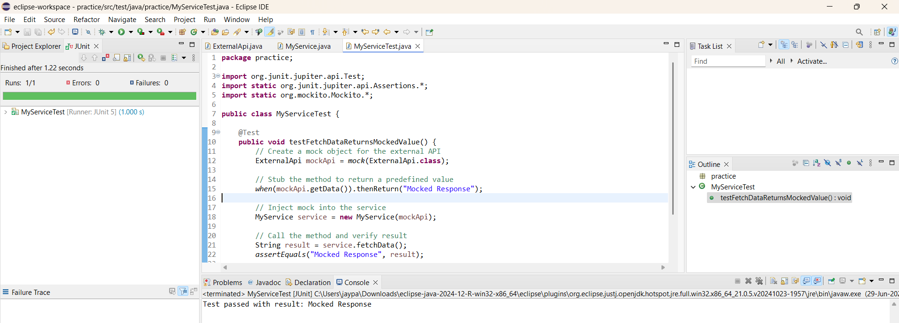

**Exercise 2: Verifying Interactions**

**ExternalAPI.java:**

package practice;

public interface ExternalApi {

String getData();

}

**MyService.java:**

package practice;

public class MyService {

private ExternalApi api;

public MyService(ExternalApi api) {

this.api = api;

}

public String fetchData() {

return api.getData();

}

}

**MyServiceTest1.java:**

package practice;

import org.junit.jupiter.api.Test;

import static org.mockito.Mockito.*;

public class MyServiceTest1 {

@Test

public void testVerifyInteraction() {

// Create a mock

ExternalApi mockApi = *mock*(ExternalApi.class);

// Use the mock

MyService service = new MyService(mockApi);

service.fetchData(); // this should call mockApi.getData()

// Verify interaction

*verify*(mockApi).getData();

System.*out*.println("Verified that getData() was called");

}

}

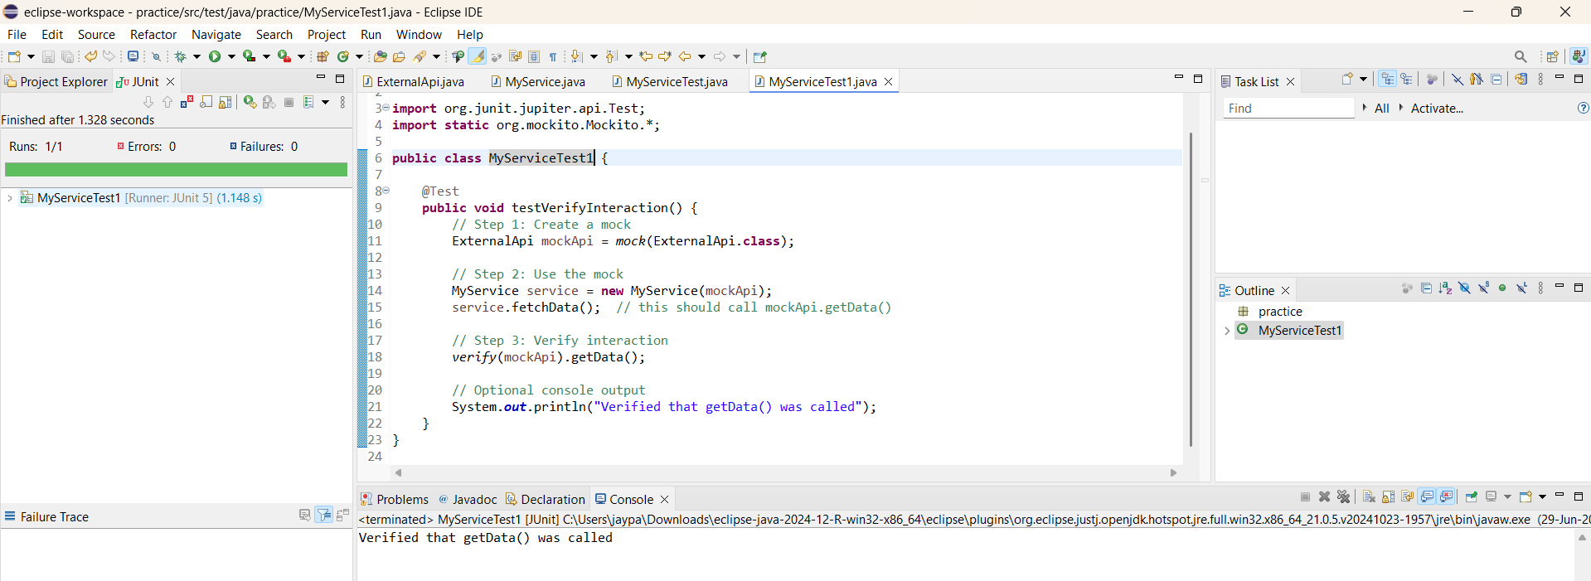

**SL4J Logging exercises**

**Exercise 1: Logging Error Messages and Warning Levels**

**pom.xml :**

<dependency>

<groupId>org.slf4j</groupId>

<artifactId>slf4j-api</artifactId>

<version>1.7.30</version>

</dependency>

<dependency>

<groupId>ch.qos.logback</groupId>

<artifactId>logback-classic</artifactId>

<version>1.2.3</version>

</dependency>

**LoggingDemo.java**

package practice;

import org.slf4j.Logger;

import org.slf4j.LoggerFactory;

public class LoggingDemo {

private static final Logger logger = LoggerFactory.getLogger(LoggingDemo.class);

public static void main(String[] args) {

logger.error("Error: Unable to connect to the server");

logger.warn("Warning: Low memory detected");

logger.info("Info: Logging system is active");

}

}

